Python Programming Assignment

# Coding Exercises

# Exercise 1: Prime Numbers

Write a Python program that checks whether a given number is prime or not. A prime number is a natural number greater than 1 that has no positive divisors other than 1 and itself.

1. PFA the python code for the above problem statement

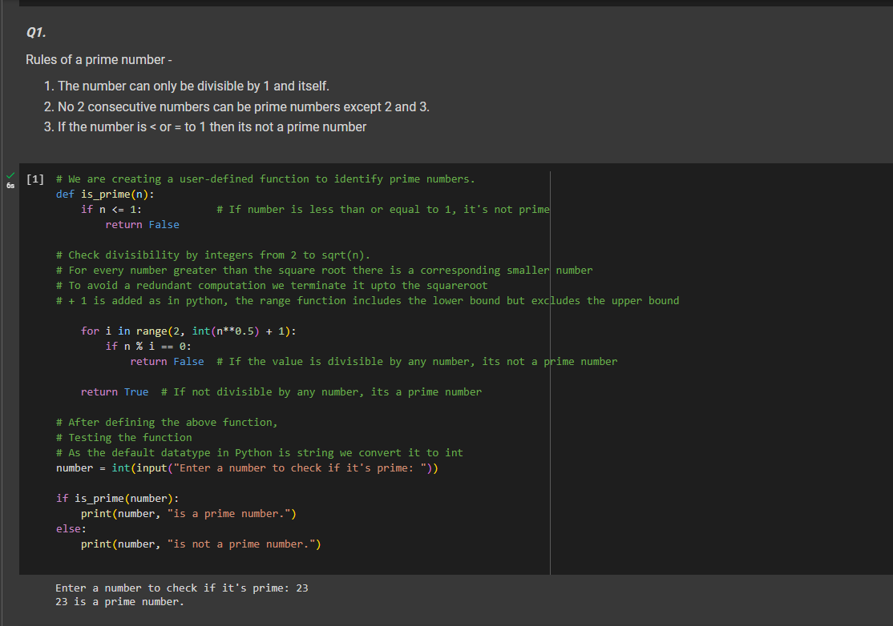

### Exercise 2: Product of Random Numbers

Develop a Python program that generates two random numbers and asks the user to enter the product of these numbers. The program should then check if the user's answer is correct and display an appropriate message.

1. PFA the python code for the above problem statement

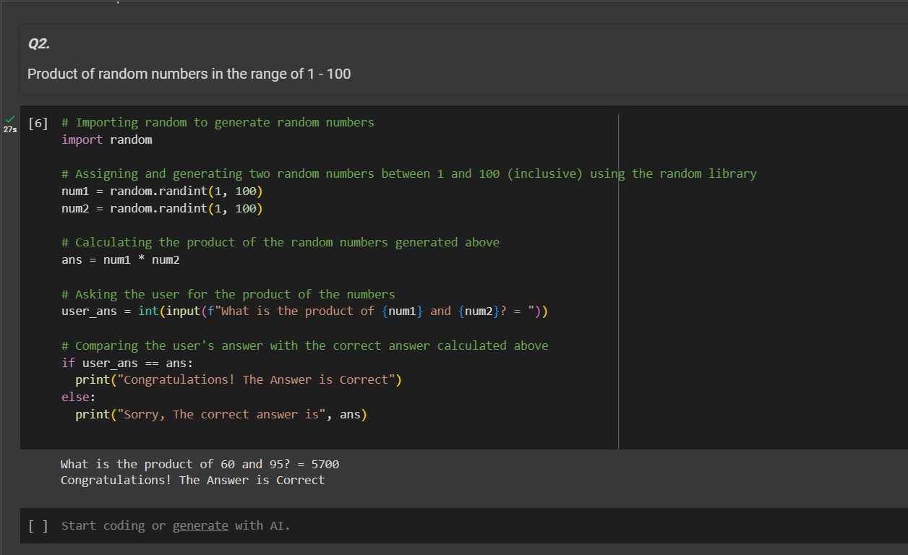

### Exercise 3: Squares of Even/Odd Numbers

Create a Python script that prints the squares of all even or odd numbers within the range of 100 to 200. Choose either even or odd numbers and document your choice in the code.

1. PFA the python code for the above problem statement

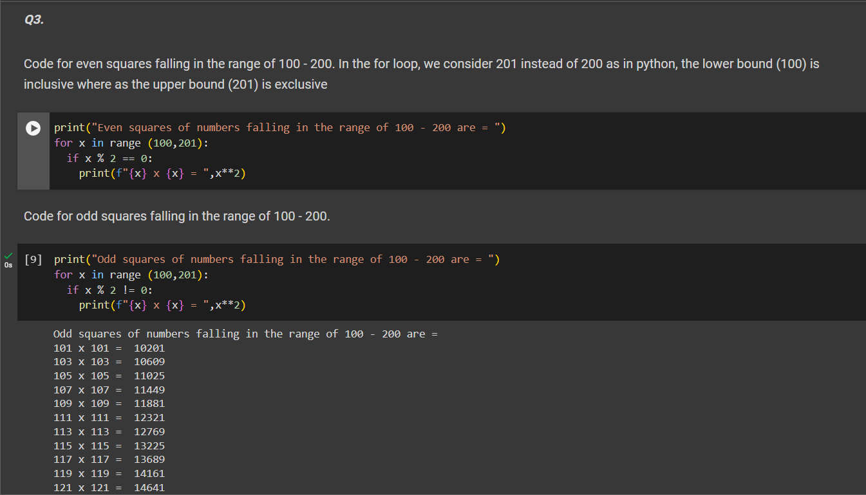

**Exercise 4: Word counter**

write a program to count the number of words in a given text.

example:

input_text = "This is a sample text. This text will be used to demonstrate the word counter."

Expected output:

'This': 2

'is': 1

'a': 1

'sample': 1

'text.': 1

1. PFA the python code for the above problem statement

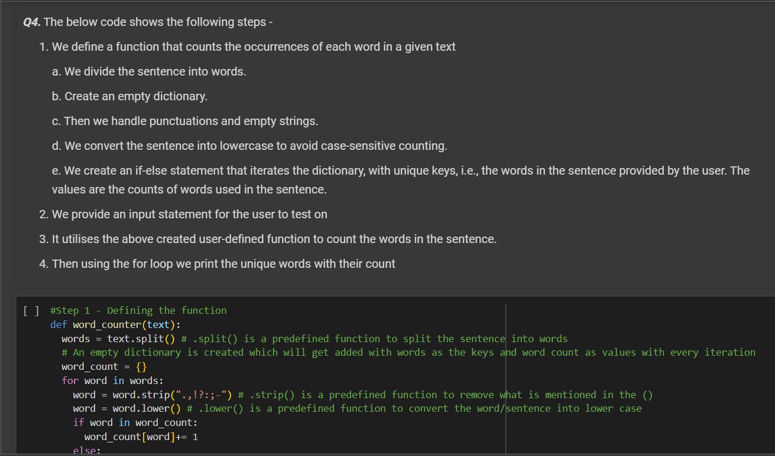

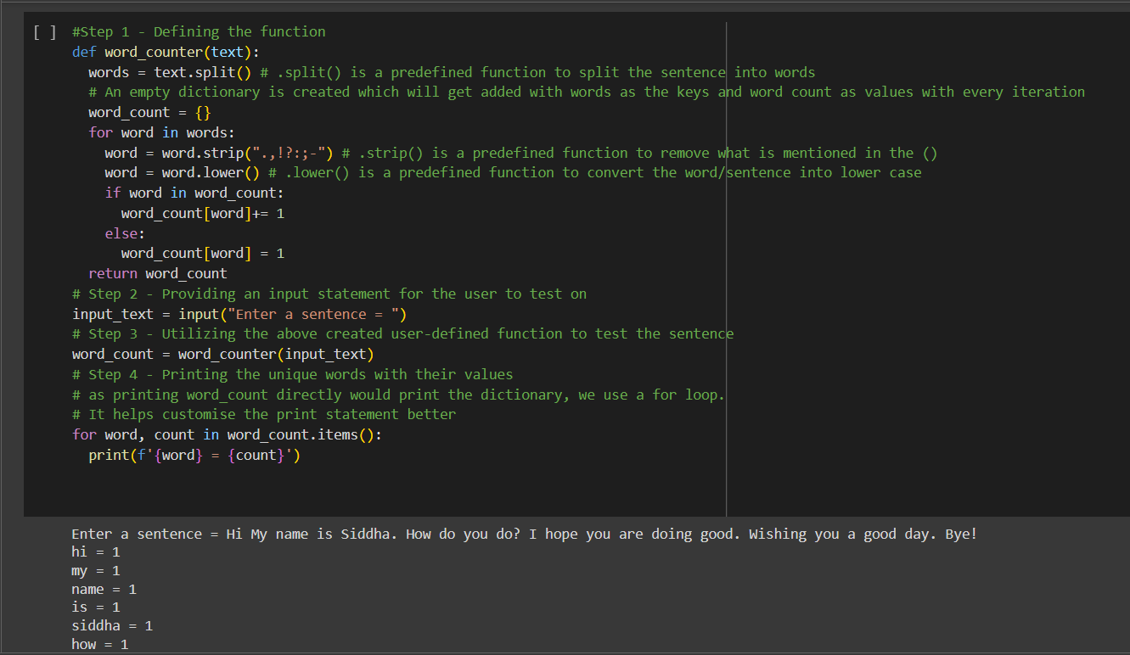

**Exercise 5: Check for Palindrome**

Write a Python function called is_palindrome that takes a string as input and returns True if the string is a palindrome, and False otherwise. A palindrome is a word, phrase, number, or other sequence of characters that reads the same forward and backward, ignoring spaces, punctuation, and capitalization**.**

**Example:**

**Input: "racecar"**

**Expected Output: True**

1. PFA the python code for the above problem statement

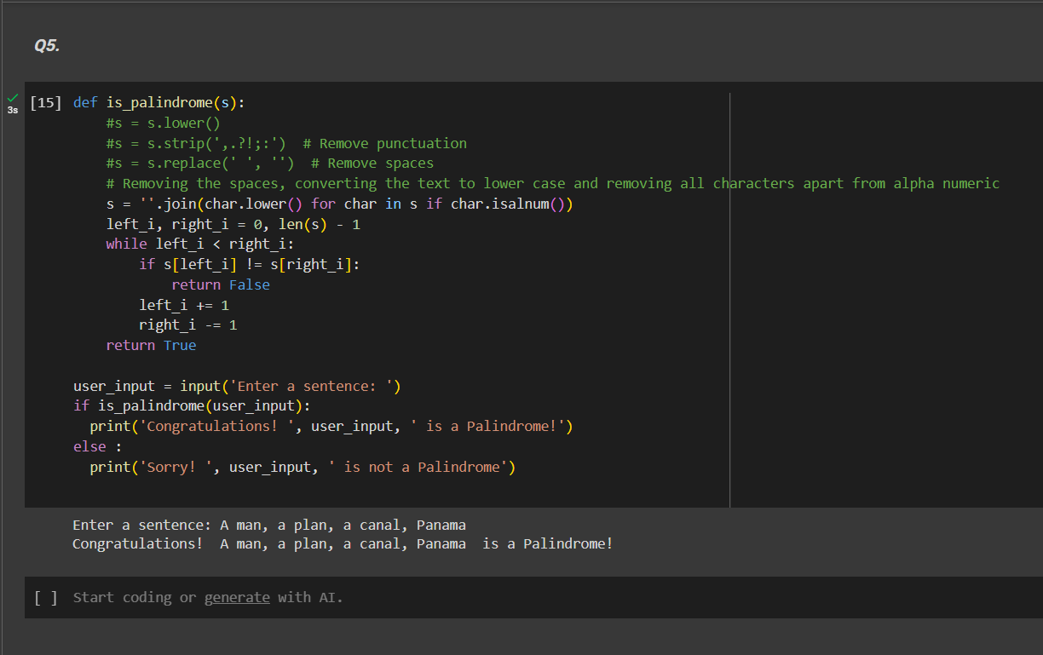

Please complete the coding exercises and answer the theoretical questions. Submit your work in a single Python (.ipynb) file for the coding exercises.Ensure your code is well-commented to explain your logic and approach. Good luck!